You are given an array arr[], the task is to return a list elements of arr in alternate order (starting from index 0).

Examples:

Input: arr[] = [1, 2, 3, 4]

Output: 1 3

Explanation:

Take first element: 1

Skip second element: 2

Take third element: 3

Skip fourth element: 4

ans:import java.util.Scanner;

public class Main

{

public static void main(String[] args) {

Scanner scanner= new Scanner(System.in);

System.out.println("enter n:");

int n=scanner.nextInt();

System.out.println("enter array input:");

int []arr=new int[n];

for (int i = 0; i < n; i++) {

arr[i] = scanner.nextInt();

}

for(int i=0;i<n;i=i+2)

{

System.out.println(arr[i]+"");

}

}

}

output: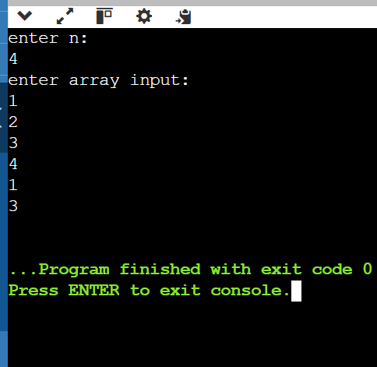_________________________________________________________________________

Input: arr[] = [1, 2, 3, 4, 5]

Output: 1 3 5

Explanation:

Take first element: 1

Skip second element: 2

Take third element: 3

Skip fourth element: 4

Take fifth element: 5

output:

_________________________________________________________________________

Given an array arr of integers and an index key(0-based index). Your task is to return the element present at the index key in the array.

Input: key = 2 , arr = [10, 20, 30, 40, 50]

Output: 30

Explanation: The value of arr[2] is 30 .

Input: key = 4 , arr = [10, 20, 30, 40, 50, 60, 70]

Output: 50

Explanation: The value of the arr[4] is 50 .

ans:import java.util.Scanner;

public class Main

{

public static void main(String[] args) {

Scanner scanner= new Scanner(System.in);

System.out.println("enter n:");

int n=scanner.nextInt();

System.out.println("enter array input:");

int []arr=new int[n];

for (int i = 0; i < n; i++) {

arr[i] = scanner.nextInt();

}

System.out.println("enter key:");

int key=scanner.nextInt();

System.out.println(arr[key]);

}

}

output:enter n:

5

enter array input:

10

20

30

40

50

enter key:

2

30

____________________________________________

Sample2

enter n:

7

enter array input:

10

20

30

40

50

60

70

enter key:

4

50

_________________________________________________________________________

Given an array arr, the task is to find whether the arr is palindrome or not. If the arr is palindrome then return true else return false.

An array is said to be palindrome if its reverse array matches the original array.

Examples:

Input: arr = [1, 2, 3, 2, 1]

Output: true

Explanation: Here we can see we have [1, 2, 3, 2, 1] if we reverse it we can find [1, 2, 3, 2, 1] which is the same as before. So, the answer is true.

Input: arr = [1, 2, 3, 4, 5]

Output: false

Explanation: Here we can see we have [1, 2, 3, 4, 5] if we reverse it we find [5, 4, 3, 2, 1] which is the not same as before. So, the answer false.

ans:import java.util.Scanner;

public class Main

{

public static void main(String[] args) {

Scanner scanner = new Scanner(System.in);

System.out.println("Enter the size of the array:");

int n = scanner.nextInt();

int[] arr = new int[n];

System.out.println("Enter the elements of the array:");

for (int i = 0; i < n; i++) {

arr[i] = scanner.nextInt();

}

boolean isPalindrome = true;

for (int i = 0; i < n / 2; i++) {

if (arr[i] != arr[n - 1 - i]) {

isPalindrome = false;

break;

}

}

System.out.println(isPalindrome);

}

}

output:Enter the size of the array:

5

Enter the elements of the array:

1

2

3

2

1

true

________________________________________________

Sample 2:Enter the size of the array:

5

Enter the elements of the array:

1

2

3

4

5

false

____________________________________________________________________

Given two arrays of arr1 and arr2, the task is to calculate the product of the maximum element of the first array arr1, and minimum element of the second array arr2.

Examples :

Input : arr1 = [5, 7, 9, 3, 6, 2], arr2 = [1, 2, 6, 1, 9]

Output : 9

Explanation: The max in arr1 is 9. The min element in arr2 is 1. The product is 9*1 = 9.

ans:import java.util.Scanner;

public class Main

{

public static void main(String[] args) {

Scanner scanner = new Scanner(System.in);

System.out.println("Enter the size of the first array:");

int n1 = scanner.nextInt();

int[] arr1 = new int[n1];

System.out.println("Enter the elements of the first array:");

for (int i = 0; i < n1; i++) {

arr1[i] = scanner.nextInt();

}

System.out.println("Enter the size of the second array:");

int n2 = scanner.nextInt();

int[] arr2 = new int[n2];

System.out.println("Enter the elements of the second array:");

for (int i = 0; i < n2; i++) {

arr2[i] = scanner.nextInt();

}

int max1 = arr1[0];

for (int i = 1; i < n1; i++) {

if (arr1[i] > max1) {

max1 = arr1[i];

}

}

int min2 = arr2[0];

for (int i = 1; i < n2; i++) {

if (arr2[i] < min2) {

min2 = arr2[i];

}

}

int product = max1 * min2;

System.out.println(product);

}

}

output:Enter the size of the first array:

6

Enter the elements of the first array:

5

7

9

3

6

2

Enter the size of the second array:

5

Enter the elements of the second array:

1

2

6

1

9

9

______________________

Sample 2:

Enter the size of the first array:

4

Enter the elements of the first array:

0

0

0

0

Enter the size of the second array:

3

Enter the elements of the second array:

1

2

1

0

______________________________________________________________________

Given a range [L, R]. The task is to find the sum of all the prime numbers in the given range from L to R both inclusive.

**Examples**:

**Input** : L = 10, R = 20

**Output** : Sum = 60

Prime numbers between [10, 20] are:

11, 13, 17, 19

Therefore, sum = 11 + 13 + 17 + 19 = 60

**Input** : L = 15, R = 25

**Output** : Sum = 59

Note: Use sieve of eratosthenes to solve the problem

ans:import java.util.ArrayList;

class Solution {

static int sumOfPrimesInRange(int L, int R) {

boolean[] isPrime = new boolean[R + 1];

for (int i = 2; i <= R; i++) {

isPrime[i] = true;

}

for (int i = 2; i * i <= R; i++) {

if (isPrime[i]) {

for (int j = i * i; j <= R; j += i) {

isPrime[j] = false;

}

}

}

int sum = 0;

for (int i = L; i <= R; i++) {

if (isPrime[i]) {

sum += i;

}

}

return sum;

}

public static void main(String[] args) {

int L = 10;

int R = 20;

System.out.println("Sum = " + sumOfPrimesInRange(L, R));

L = 15;

R = 25;

System.out.println("Sum = " + sumOfPrimesInRange(L, R));

}

}

__________________________________________________________________